User
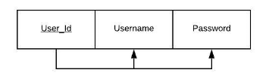

Person
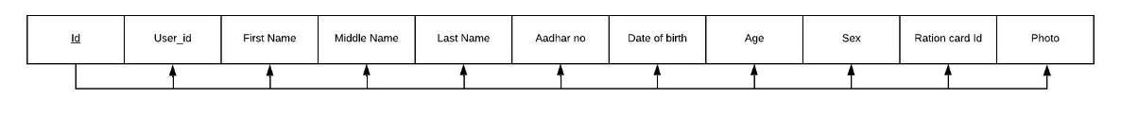

Ration-card
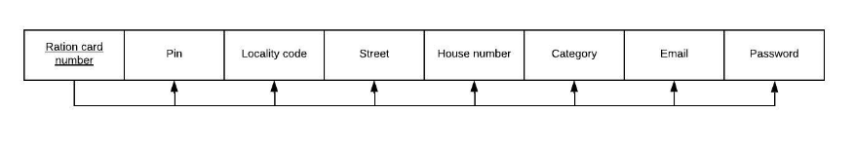
Transaction
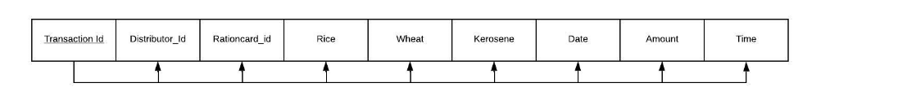

Circular
